Farmers ZSOA
Zurich Services Oriented Architecture

FNOL – WC Intermediary Information Management Service
Technical Design

Version 1.0



Farmers Service Competency Center

Copyright Zurich Financial Services

Document History

Version | Date | Author | Comment
1.0 | 06/27/2008 | Emmanuel Ameh | Initial Draft

Table of Contents
1 About this Document 5
1.1 Introduction 5
1.2 Intended Audience 5
1.3 How this document is organized 5
1.4 Reference Architecture 5
1.5 Service Overview 7
Orchestration Layer Components 8
1.6 ESB Components 8
1.6.1 ALSB 8
1.7 Client interface 9
1.8 Message flow 10
1.9 Transformations 10
1.10 Routing 10
2 Service Enablement Layer Components 11
2.1 Interface 11
2.1.1 Functionality Required 11
2.1.2 Inputs 11
2.1.3 Outputs 11
2.1.4 Faults 12
2.1.5 Data Modifications 13
2.1.6 Logical Flowchart 13
3 Implementation Layer Components 14
3.1 Class Diagram 14
3.2 Mainframe Programs 15
3.2.1 Program Name 15
3.2.2 Region 15
3.2.3 Linkage section 15
3.2.4 Procedure Division declaration 15
3.3 EJB’s 15
3.4 Database\Stored Procedures 15
4 Functional\Non-functional requirements 16
4.1 Functional 16
4.1.1 Feature specifications 16
4.2 Non-functional 16
4.2.1 Security 16
4.2.2 Logging 16
Logging is provided by Amber-point 16
4.2.3 Monitoring 16
4.2.4 Business exception handling 16
4.2.5 Response time 16
4.2.6 Concurrent Users 16
4.2.7 Throughput Requirements 16
4.2.8 Availability 16
5 Business Contacts 17

About this Document

Introduction
This document describes the design artifacts and implementation model of the Intermediary Information Management Service. Although external systems (upstream and downstream) are referenced in this document, their detailed behavior falls outside the scope of this document. Overall system requirements are covered in the requirements and use case document and, therefore, also fall outside the scope of this document.

Intended Audience
This document is intended for the team members who will be responsible for development of this service.

How this document is organized
The design for the Intermediary Information Management Service is presented in 4 areas of interest as outlined below.
- Orchestration Layer Components: Presents the services, components and information pertinent to this level. The primary focus here is on the Enterprise Service Bus and the activities carried out there.
- Service Enablement Layer Components: Describes the design and pertinent aspects needed to develop the atomic services as well as any other aspects implemented at this level.
- Implementation Layer Components: This deals primarily with backend or legacy data sources and the design to follow in exposing their services to the enterprise.
- Functional\Non-functional Requirements: This section outlines the functional and non-functional requirements identified for this service.

Reference Architecture
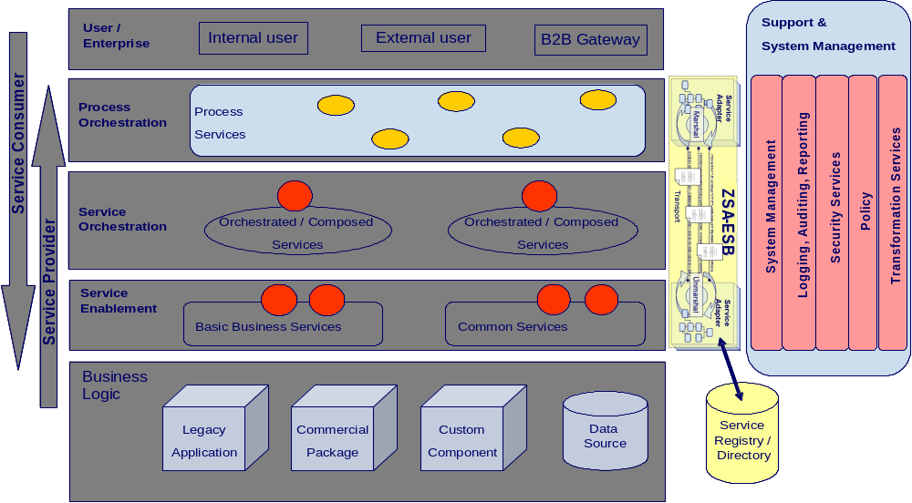

Fig 1.1
As shown in the above diagram, the Intermediary Information Management Service will follow the reference architecture defined in the “ZSA_Tech_Ref_Architecture” document.
No special implementation is required for security and transformation for providing web services to the (Consumer). The details of the base implementation are explained below:
The end-to-end flow for the provider NWCS will follow the steps shown in the diagram 1.2:

FNOL - AUTO

O R

LOAD BALANCER

ALSB
retrieveAgentDetails( )

iNET
(Service Enablement Component)

O R

LDAP
(INTERNALPROVIDER)

Diagram 1.2

As shown in diagram 1.2, FNOL – Auto, the consumer system, sends a set of data elements in the request message as string and gets a response which contains: Contact Type, Entity Type, First Name, Last Name, Vendor Type, Vendor Name, Address, City, State, Zip, Phone, Fax, as well as the email address.
Here, Intermediary Information Management Service component returns provider location and contact information (includes address and organization) as well in the response message.

Service Overview
This service will return the provider information, as well as the location information depending on the input data elements provided by the service consumer.
As per the reference architecture, Channel Management Object has implementation components in the Service Enablement, Atomic, and Orchestrated layers.

.

Anticipated URLs for provider search results INET will provide: None

Orchestration Layer Components

ESB Components

ALSB

1.6.1.1 Business Service
This section contains the detail necessary to define the business service in the ESB.

General Configuration
Service Name | Intermediary Information Management - Business Service
Description | The purpose of Intermediary Information Management service is to retrieve agents’ detailed information as well as the location information based on the input data elements. If the agent Code is given as the only input parameter there is only one result in the response message from the provider system. If agent code is missing in the request message there is a list of agents within the response message.
Service Type | Web service
Transport Configuration
Protocol | HTTP
Load balancing | No
Endpoint URI | http://services.farmersinsurance.com/services/<<tbd>>
Retry count | 0
Retry interval | 0 seconds
HTTP Transport Configuration
Timeout | Default to server
HTTP Request Method | Post
Authentication | No
Follow HTTP redirects | No
SOAP Binding Configuration
Enforce WS-I Compliance | Yes

1.6.1.2 Proxy Service
This section contains the detail necessary to define the proxy service in the ESB.

General Configuration
Service Name | Intermediary Information Management Proxy Service
Description | This service fronts the primary business service
Service Type | WSDL Web Service
Proxy Service Provider | N/A
Protocol | HTTP
Endpoint URI | http://services.farmersinsurance.com/services/<<tbd>>_proxyService
Get All Headers | No
Headers | N/A
HTTP Transport Configuration
Authentication | No
Message Level Security Configuration
Custom Authentication | No
Operation Selection Configuration
Enforce WS-I Compliance | Yes
Selection Algorithm | SOAP Body Type

1.6.1.3 WSDL


Client interface
A consumer will access this service via a WS-I v1.1-compliant web service invocation. This service uses the wrapped document literal binding style. The request/response messages are in IAA canonical format and the consumer has the responsibility to map the XML message structure to their internal format.

Message flow
Message Flows are the definitions of AquaLogic Service Bus proxy services. Pipelines (Request and Response pipelines), branch nodes, and route nodes define the implementation of AquaLogic Service Bus proxy services. There will be a Pipeline Pair required to handle the request and response, and Route node required and there is no requirement for branch nodes. ALSB which provides a route node is used to perform request/response communication with Proxy service and provider service. The route node supports conditional routing as well as request and response transformations. There are no transformations within the Intermediary Information Management Service.

Transformations
Data transformation is the mapping of data from one format to another. DataPower transforms messages from IAA format to the service provider’s format. It uses the Xquery, XSLT transformation and XPath language for data composition and transformation for service endpoints. Data power supports data mapping that uses XQuery and the eXtensible Stylesheet Language Transformation (XSLT) standards. There is only one transformation component at the Data Power for transforming IAA service request (IAA message) to NWCS service request. There is no data transformation since provider system identifies SOAP/HTTP messages.

Routing
There is no need for routing as there is only one provider for the consumer of this service. FNOL - Auto is sending request to NWCS system. In order to route the consumer requests to different providers, we follow content based routing.

Service Enablement Layer Components

Interface
The Intermediary Information Management Service is to be the result of building a service layer to interact with new third party providers (agents).

Functionality Required
A new service is to be enabled under Channel Management Package in IAA. The WSDL files to be implemented for this service are located in section 1.6.1.3. Service enabling this new calling program will require mapping of the ZIAA canonical model to the existing inputs and outputs. The following table shows the native input\output elements to ZIAA WSDL mappings.
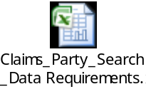

Inputs
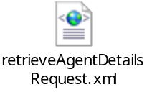
Use Case Parameter | Type | Element | Schema
Agent Code | String | agentCode | Intermediary.xsd
First Name | String | firstName | Intermediary.xsd
Last Name | String | lastName | Intermediary.xsd
State Code | String | stateCode | Intermediary.xsd

Outputs
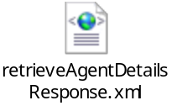

Use Case Parameter | Type | Element | Schema
District Code | String | districtCode | Intermediary.xsd
Division Code | String | divisionCode | Intermediary.xsd
Region Code | String | regionCode | Intermediary.xsd
State Code | String | stateCode | Intermediary.xsd
Agent Code | String | agentCode | Intermediary.xsd
Aca Code | String | acaCode | Intermediary.xsd
Primary FeoAgent | String | primaryFeoAgent | Intermediary.xsd
Secondary Code | String | secondaryCode | Intermediary.xsd
Agency Name | String | agencyName | Intermediary.xsd
First Name | String | firstName | Intermediary.xsd
Last Name | String | lastName | Intermediary.xsd
Middle Name | String | middleName | Intermediary.xsd
city | String | city | Intermediary.xsd
MailingCity | String | mailingCity | Intermediary.xsd
MailingState | String | mailingState | Intermediary.xsd
MailingZip | String | mailingZip | Intermediary.xsd
State | String | state | Intermediary.xsd
emailAddress | String | emailAddress | Intermediary.xsd
Phone Number | String | phoneNumber | Intermediary.xsd
Fax Number | String | faxNumber | Intermediary.xsd
Commercial License | String | commercialLicense | Intermediary.xsd
Farmers License | String | farmersLicense | Intermediary.xsd
Ffs License | String | ffsLicense | Intermediary.xsd
Fire License | String | fireLicense | Intermediary.xsd
Life License | String | lifeLicense | Intermediary.xsd
Mca License | String | mcaLicense | Intermediary.xsd
Sec License | String | secLicense | Intermediary.xsd
State License | String | stateLicense | Intermediary.xsd
channel | String | channel | Intermediary.xsd
Original Channel | String | originalChannel | Intermediary.xsd
role | String | role | Intermediary.xsd
Agent of Record | String | agentOfRecord | Intermediary.xsd
Dual user codes | String | dualUserCodes | Intermediary.xsd
Produce Code | String | produceCode | Intermediary.xsd
Racf Id | String | racfId | Intermediary.xsd
applicationAccessIndicator | String | applicationAccessIndicator | Intermediary.xsd

Faults

U.C. Parameter | Element | Type | Schema
Technical Error | errorMessageType | String | (ZSOA.xsd)
Business Error | errorState | String | (ZSOA.xsd)

Data Modifications
Identify any data modifications which need to occur in the service enablement layer.
Field Name | Modifications
None

Logical Flowchart
Begin
Input parameters
Call Intermediary Info Service to display agent search results.
LDAP processes the request
processes the request
End
Yes
Success/failure

Create Error Message
Failure
Send response through ALSB to FNOL, Auto
Success

Implementation Layer Components

Class Diagram

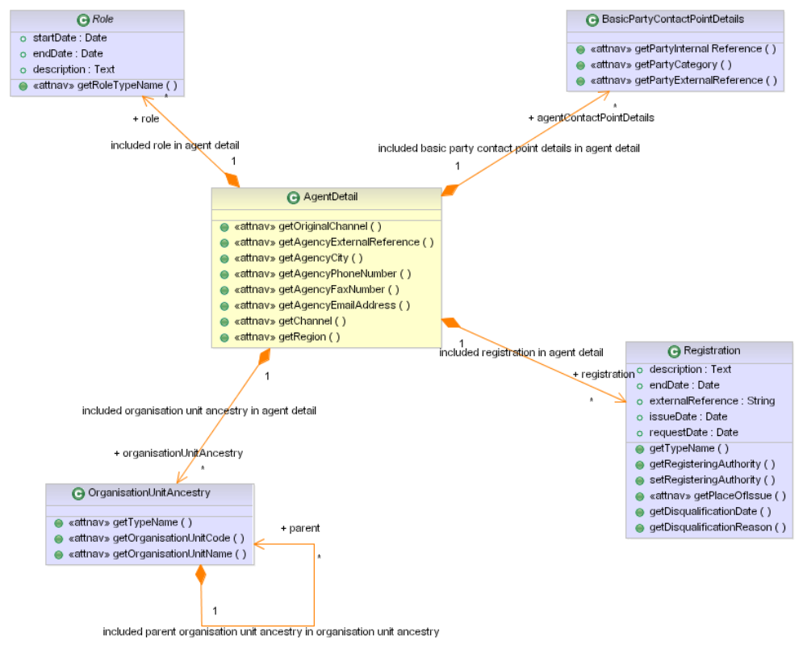

Mainframe Programs
<<None>>

Program Name
<<None>>

Region
<<None>>

Linkage section
<<None>>

Procedure Division declaration
<<None>>

EJB’s
<<None>>

Database\Stored Procedures
<<None>>

Functional\Non-functional requirements

Functional

Feature specifications
No special features are specified for the functional requirements

Non-functional

Security
Since the provider is a public network, there is no message level and transport level security needed for this service. However, the service should be accessible within the Farmers’ domain.

Logging

Logging is provided by Amber-point

Monitoring
Monitoring is performed by Amber-point

Business exception handling
Return data error message when request input is wrong.

Response time
The response time should be within 3sec.

Concurrent Users
FNOL - WC, FNOL - Auto

Throughput Requirements
The throughput expectations from FNOL - Auto system is around 30,000 (service requests) / day. For FNOL – WC it is around 300 (service requests) / day.

Availability
As far as availability is concerned, the Intermediary Information Management Service is available 100% of the time.

Business Contacts
Name | Company | Role | Email address
Kathy Hartley | Famers,HO | Program Manager | kathy_hartley@farmersinsurance.com
Goutham Nellutla | Farmers | Program Manager, Farmers Services Competency Center | goutham.nellutla@farmersinsurance.com
Mukesh Agrawal | Farmers | Program Manager | Mukesh.agrawal@farmersinsurance.com
Venkata Pushpala | FNOL - WC | Integration Team Lead | Venkatakrishna.pushpala@farmersinsurance.com

